Sales Performance Management System

User Manual

Version 0.1

Confidentiality Statement

This document is strictly private and confidential. The information included has been prepared and included for the purpose of this document only and shall not be used as a model or used in any other situation.

Distribution List (in Alphabetic Order)

Approving Committee (in alphabetic order)

Name | Organization

Each subsequent version of this document must be described below and recorded by the person who made the changes:

Revision History

Revision Date | Version | Updated by | Summary of Changes
29/04/2010 | 0.1 | Li Qun | Initial revision

Table of Contents

1. Introduction 1
2. Audience 1
2.1. Team Lead 1
2.2. Dealer 1
2.3. Administrator 1
3. Overview 1
4. Common Features 2
4.1. Sorting 3
4.2. Pagination 3
4.3. Export to Excel File 3
4.4. Calendar 4
5. Login 5
6. Assignment Management 6
6.1. Assignment (Intra-Team) 6
6.2. Cross Team Assignment 9
6.3. Assignment History 10
6.4. Assigned Client Info 10
7. Contact Management 11
7.1. Contact Entry 11
7.2. Contact Entry Admin 13
7.3. Contact History 13
7.4. Call Report 14
7.5. Contact Analysis 15
7.6. Client Analysis 16
8. Setup 16
8.1. Core Client Setup 16
8.2. Client Short Key Setup 17
8.3. Dealer Management 18
8.4. Cross Team Setup 20
8.5. Preference List Setup 21
9. Access Management 22
10. Glossary 24

Table of Figures

Figure 1 – Common Features: Sorting, Pagination and Export to Excel File 2
Figure 2 – Save Excel File Screen 1 3
Figure 3 – Save Excel File Screen 2 4
Figure 4 – Calendar 4
Figure 5 – Login Screen 5
Figure 6 – SPM Main Menu 5
Figure 7 – Assignment Search Criteria Screen 6
Figure 8 – Assignment Search Result Screen 7
Figure 9 – Auto Assignment Screen 8
Figure 10 – Assignment History Screen 10
Figure 11 – Assigned Client Info Screen 10
Figure 12 – Contact Entry Screen 1 11
Figure 13 – Contact Entry Screen 2 12
Figure 14 – Contact Entry Screen 1 13
Figure 15 – Contact History Screen 14
Figure 16 – Call Report Screen 15
Figure 17 – Contact Analysis Screen 15
Figure 18 – Client Analysis Screen 16
Figure 19 – Core Client Setup Screen 16
Figure 20 – Client Short Key Setup Screen 17
Figure 21 – Dealer Management Screen 1 18
Figure 22 – Dealer Management Screen 2 19
Figure 23 – Cross Team Setup Screen 20
Figure 24 – Preference List Setup Screen 21
Figure 25 – POEMS Admin Access Rights Management Screen 22
Figure 26 – SPM Access Rights Management Screen 23

Introduction
The Sales Performance Management (herein after referred as SPM) system is designed for dealers to reactivate dormant accounts in order to increase sales. Team leaders can also monitor the performance of each dealer – how many calls made or missed, how many dormant accounts start trading after the calls.

This is the user manual of SPM which covers the detailed procedures on how to use each of the functions in the system.

Audience
There are following 3 types of users who will be using the SPM system:
- Team Lead
- Dealer
- Administrator

Team Lead
Team Leads are usually branches managers or designated supervisor who will assign dormant accounts to dealers to follow up and monitor dealer’s performances

Dealer
Dealer will make calls to assigned clients and will enter the contact details into the system

Administrator
Also called Moderator, Administrator of the SPM system will manage dealer and user information, grant user access of functions, setup cross team assignment mapping and maintain the client preference codes

Overview
Clients are considered as dormant accounts if they meet the criteria of 2N Rule:
- Have cash and/or stocks in their account
- But haven’t traded for the last three months

Team leaders will pull out the dormant accounts based on the 2N Rule and assign them to selected dealers. The dealer assigned should call the assigned clients and enter the contact details within the given time frame; otherwise the assignment will be counted as missed call.

Each client belongs to only one team which is called Trading Representative (hereafter referred as TR). The dealers are grouped into teams. Each Team has a team code (TR Code) and a team name (TR Name). Each team has a team leader and a few dealers.

The system has the following functions

Assignment Management
- Client Assignment (Intra Team)
- Cross Team Assignment
- Assignment History
- Assigned Client Info

Contact Management
- Contact Entry
- Contact Entry Admin
- Contact History
- Call Report
- Contact Analysis
- Client Analysis

Setup
- Core Client Setup
- Client Short Key Setup
- Dealer Management
- Cross Team Setup
- Preference List Setup

Access Control
- Access Management

Common Features
There are the following common features for all the functions as shown in Figure 1:
    - Sorting
    - Pagination
    - Export to Excel File
    - Calendar

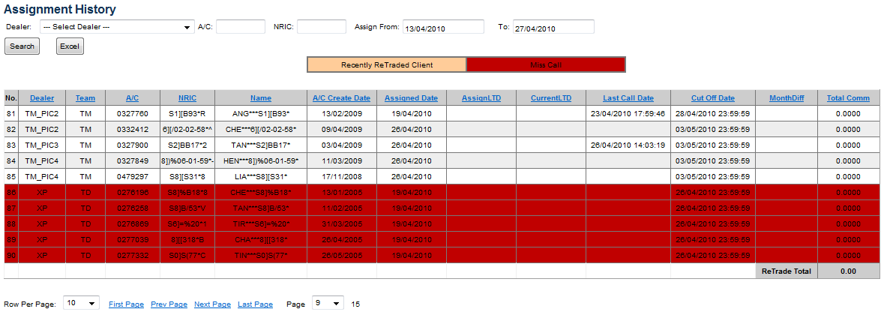

Figure 1 – Common Features: Sorting, Pagination and Export to Excel File

Sorting
For those functions with sorting features, you can sort the retrieved records by clicking the respective sortable header column such as Client Account No, Name, etc. 1st click will sort in ascending order. Subsequent click will sort in the reversed order.

Pagination
For those functions with pagination features, you can navigate from one page to another page by either:
    - Clicking the “First Page” button to go to the first page if the current page is not the first page
    - Clicking the “Prev Page” button to go to the previous page if the current page is not not at the first page
    - Clicking the “Next Page” button to go to the next page if the current page is not the last page
    - Clicking the “Last Page” button to go to the last page if the current page is not the last page
    - Selecting the page from the page number dropdown list

Each function has its own default value for number of records per page. You can change the number of records per page by selection a number from the “Row Per Page” dropdown list.

Export to Excel File
For those functions with Export to Excel features, you can export the retrieved records into Excel file by clicking the “Excel” button. System will display the following dialog box:

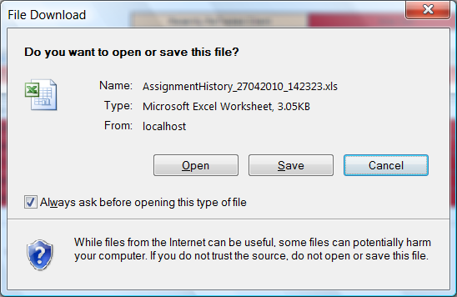

Figure 2 – Save Excel File Screen 1

To open the Excel file directly, click “Open” button. System will open the excel file. Click “Cancel” button to cancel.

To save the Excel file, click “Save” button. System will ask you to specify a location for the file as shown below.

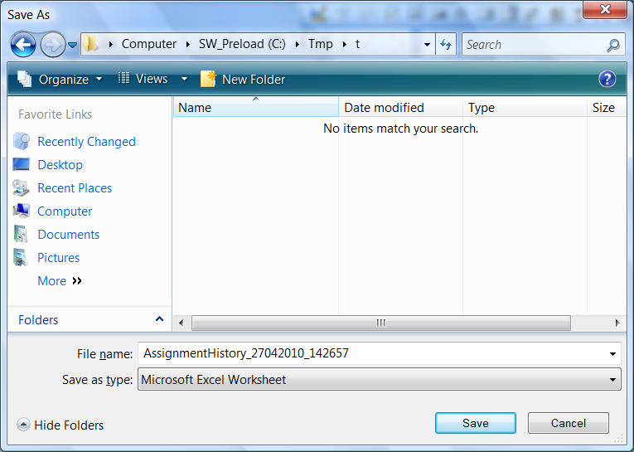

Figure 3 – Save Excel File Screen 2

Click “Save” button to save the file into the specified location or click “Cancel” button to cancel the save.

Calendar
For all the functions that require input of date values, you can select a date from the calendar.

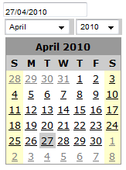 | 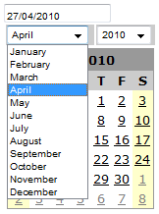 | 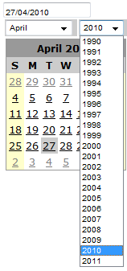

Figure 4 – Calendar

To activate the calendar, click the date field. System will display the calendar of the month as per the value in the date field, or the current month with today is selected if the value in the date field is empty.

To select a date from the calendar, click the date on the calendar. System will change the value in the date field to the selected date.

To navigate to another month, select the respective month from the month dropdown list which will show all the 12 months of a year.

To navigate to another year, select the respective year from the year dropdown list which will show year from 1990 to next year of current year.

Login
As the SPM system is part of the POEMS Admin system, you need to login into POEMS Admin to access the SPM system:

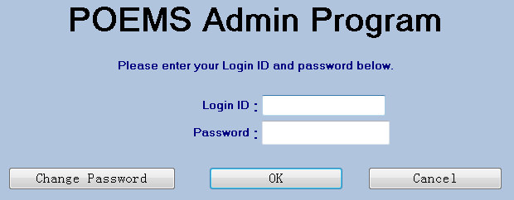

Figure 5 – Login Screen

After login successfully, click “CUSTOMER SUPPORT” then click “Call Center” . You will see the “Sales Performance Management” option on the left panel. Click “Sales Performance Management” option, system will bring up the SPM main menu which will show all the functions available for you.

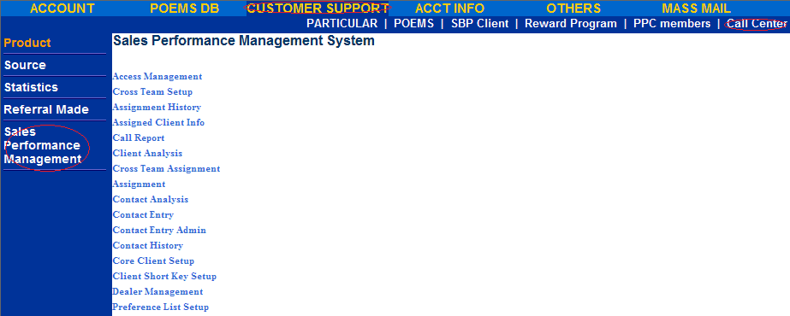
Figure 6 – SPM Main Menu

You can access each function by clicking on the function on the SPM main menu.

Assignment Management

Assignment (Intra-Team)
This function allows the team lead to assign clients to dealers within the team. You can also retrieve, view and modify the existing assignments.

Click “Assignment” option on the SPM main menu, system will display the search criteria screen:
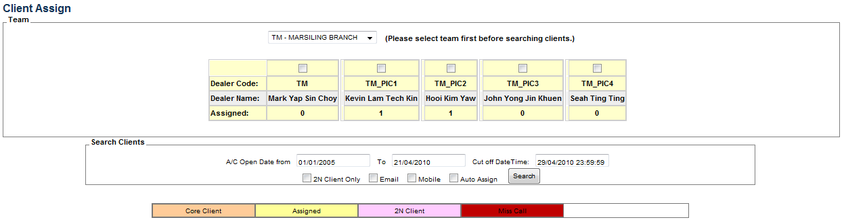

Figure 7 – Assignment Search Criteria Screen

Select a team from team dropdown list, system will display all the dealers under the selected team. You can select dealers for auto assignment by ticking the respective dealers. For auto assignment, you will also need to tick the auto assign check box.

Enter the following search criteria:
    - The account opening date range (enter using “dd/mm/yyyy” format or click to open a calendar to select a day)
    - 2N Client Only Flag (tick to retrieve only 2N client)
    - Email flag (tick to only retrieve clients who have email address)
    - Mobile flag (tick to only retrieve clients who have mobile phone number)

Also enter the following:
    - Cutoff date (the due date of the assignment, default to one week after today’s day. Assigned dealer must contact client and enter the contact record by the cutoff date, otherwise it will be counted as miss call)
    - Auto-Assign flag (tick to allow auto assign the retrieved clients to all the selected dealers evenly. You need to tick the dealers for auto assignment)

Click “Search” Button, system will retrieve all the clients matching the search criteria.
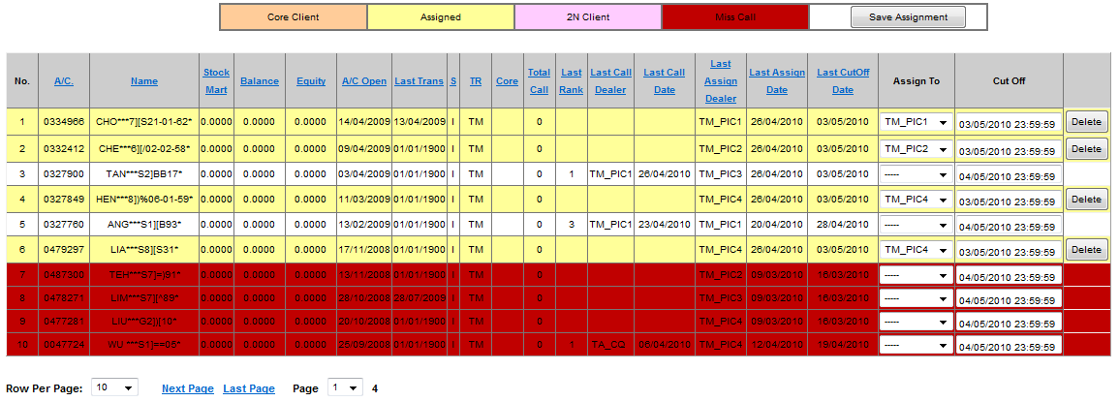
Figure 8 – Assignment Search Result Screen

System will retrieve the following clients for new assignment:
- Clients who are never assigned
- Clients who have been assigned before but already been contacted.
- Clients who have been assigned but have not been contacted and cut-off date is already due. Such assignment is considered as miss call and will be displayed in red colour
- System will set the cutoff date and time according the input cutoff date and time in the search criteria box.

System will also retrieve the following assigned clients for you to modify or delete the assignments:
- Clients who have been assigned but not contacted yet and call date is not due yet
- System will display the last assigned dealer and the cutoff date and time for you to change

For auto assignment, system will display the number of clients auto assigned to each dealer:

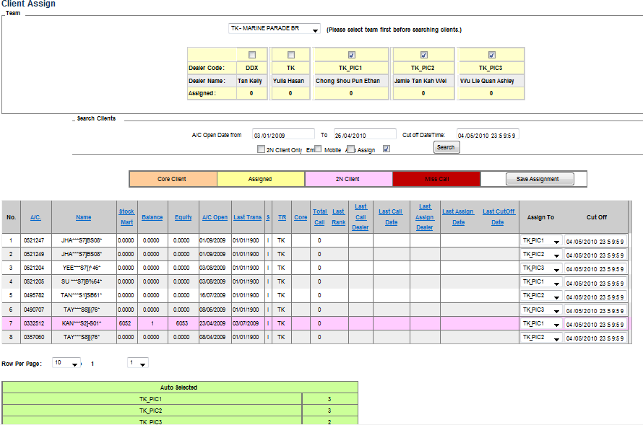

Figure 9 – Auto Assignment Screen

If there is no client matching the search criteria, you can enter new search criteria and search again.

After the clients are retrieved and displayed, you can do the following for each client:
- For new assignment, select the dealer from the dealer dropdown list in the “Assign To” column. For auto assignment, you can select a different dealer or change the dealer to empty if you don’t want to assign this client to any dealer. You can also change the default cutoff datetime which is next to the “Assign To” column. You can select a cutoff date from calendar or enter the cutoff date and time directly.
- To change an existing assignment, select a different dealer from the dealer dropdown list. You can also change the existing cutoff datetime which is next to the “Assign To” column. You can select a cutoff date from calendar or enter the cutoff date and time directly.
- To delete an existing assignment, click the “Delete” button. System will delete the assignment immediately.

After setting the dealers and cutoff date and time for each assignment, click “Save Assignment” to save the assignment.

NOTE: as the deletion is immediate upon clicking the “Delete” button, don’t click the “Save Assignment” if there is no new assignment entered or no existing assignment changed.

Refer to “Common Features” section on sorting, pagination, export to excel and calendar features.

Cross Team Assignment
Cross Team Assignment allows Team Lead to assign clients to dealers of other teams if the dealers are allowed for cross team assignment. Administrator can setup team and dealer for cross team assignment in “Cross Team Setup” Function.

The functionality of cross team assignment is basically the same as that of the intra team assignment except that the following:
- The TR code of the search criteria will only show the teams that have other teams’ dealers attached for cross team assignment.
- System will only display dealers who are from other teams but crossed attached to the specified team.
- For each client, user can only select a dealer from the above dealers

To do cross team assignment, click “Cross Team Assignment” option on the SPM main menu. Then refer to “Client Assignment (Intra Team)” section for the rest of the steps on how to do the assignments.

Assignment History
This function allows you to retrieve and view the assignment records.

Click “Assignment History” option on the SPM main menu, system will display Assignment history screen:

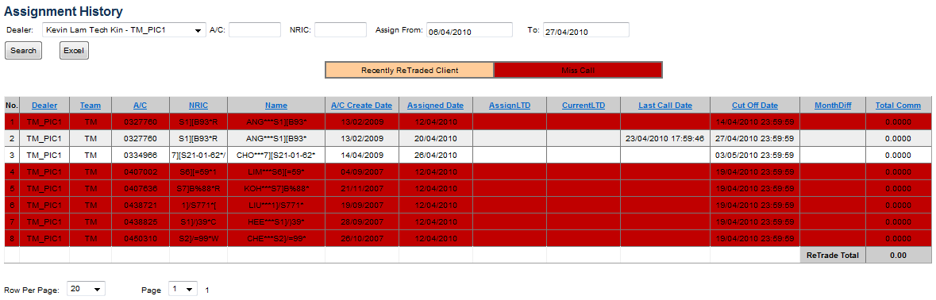
Figure 10 – Assignment History Screen

Enter the following search criteria:
- Dealer (select from dealer dropdown list or leave it blank)
- A/C No.
- NIRC
- Assignment Date Range (select from a calendar or enter directly)

Click “Search” button to retrieve the assignment records. If no record matching the specified criteria, change the search criteria and search again.

Refer to “Common Features” section on sorting, pagination, export to excel and calendar features.

Assigned Client Info
This function allows user to retrieve and view the information of assigned clients.

Click “Assigned Client Info” option on the SPM main menu, system will display Assigned Client Info screen.

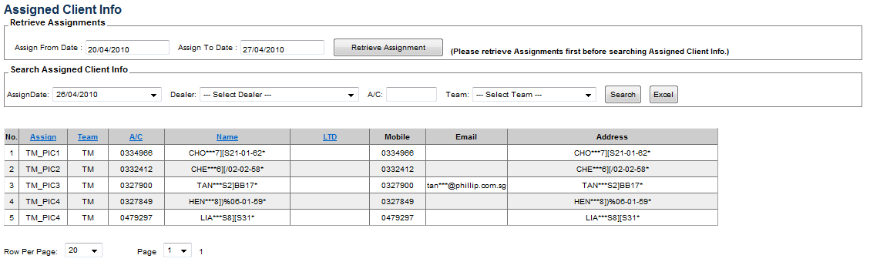
Figure 11 – Assigned Client Info Screen

First enter the assignment date range to retrieve a list of assignment dates. You can select date from calendar or enter the date directly. Then click “Retrieve Assignment” button to retrieve a list of assignment date.

Then continue to enter the following search criteria:
- Assignment Date (select from the assignment date dropdown list)
- Dealer (select from the dealer dropdown list)
- Client A/C No.
- Team (select from the team dropdown list)

Click “Search” button to retrieve the assign client information records. If no record matching the specified criteria, change the search criteria to search again.

Refer to “Common Features” section on sorting, pagination, export to excel and calendar features.

Contact Management

Contact Entry
This function allows dealer to enter the contact information records.

Click “Contact Entry” option on the SPM main menu, system will display Contact Entry screen with your current undue and un-contacted assignments on the left and the recent contact entry records at the bottom.

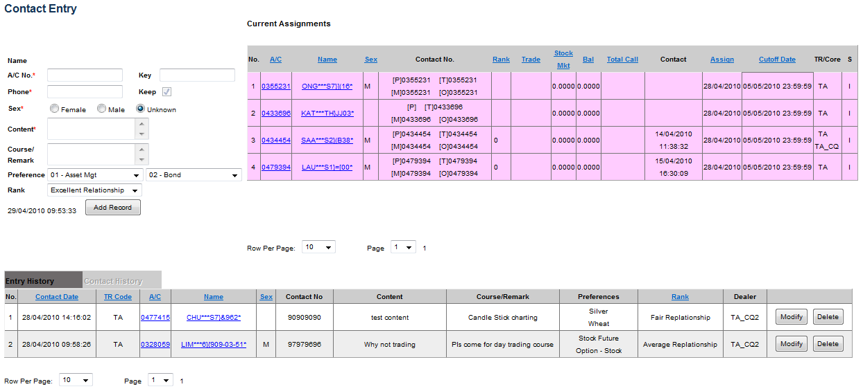
Figure 12 – Contact Entry Screen 1

Enter New Contact
To enter a new contact, select a client by clicking client A/C number on the current Assignment or Entry History panel. System will display the client name and fill up the A/C number, Phone number and sex in the contact entry panel.

You can also enter the client A/C number directly, or enter the client short key and system will pull out client name, A/C number, phone number, sex preferences and rank.

You can enter or change client’s phone number and sex.

Continue to enter the conversation details into the “Content” field and enter the courses advised to client or any remarks under “Course/Remark” field. Select or change two preferences from the respective dropdown list. Select or change the relationship from the relationship dropdown list.

Click Add button to save the new contact. If save is successful, system will remove this client from the “Current Assignments” panel if you selected the client from the assignment.

System will add and display the newly entered contact into this client “Contact History” panel at bottom of the screen. If the client contact you entered is not from the assignment, system will mark it as extra call.

System will also add the new contact into the “Entry History” panel at bottom. To view the entry history, click the “Entry History” tab at the bottom of the screen.

Modify Contact
You can modify the recently entered contact since your last assignment date or 7 days back from today, whichever is later.

To modify a contact, click the “Entry History” tab if the entry history is not displayed. Click the “Modify” button on the Entry record you want to modify. System will bring up the contact record and fill up in the contact entry panel as shown in below screen. Make necessary changes on contact record. Click “Update” the button to save the changes, or click “Cancel” to cancel the changes.

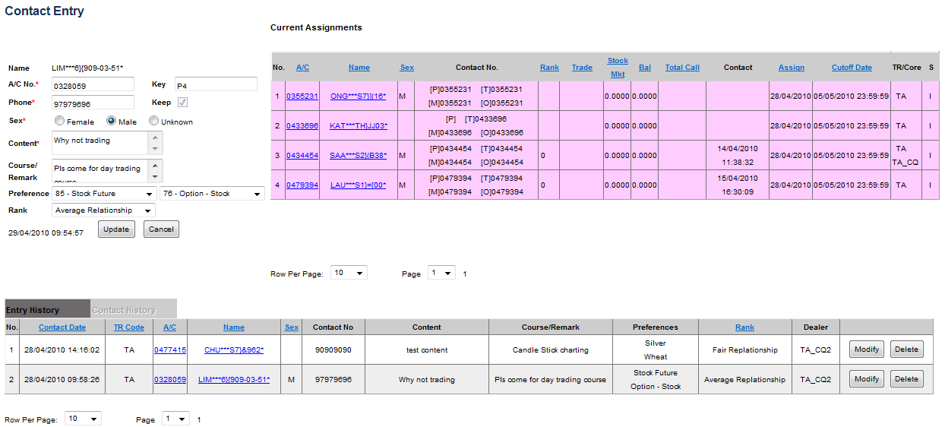
Figure 13 – Contact Entry Screen 2

Delete Contact
You can delete the recently entered contact since your last assignment date or 7 days back from today, whichever is later.

To delete a contact, click the “Entry History” tab if the entry history is not displayed. Click the “Delete” button on the Entry record you want to delete.

Contact Entry Admin
This function allow authorized user to enter contact information on behalf of the assigned dealer.

First the authorized user will select another dealer from a dropdown list of all the dealers. System will display the current assignment and entry history of the selected dealer.

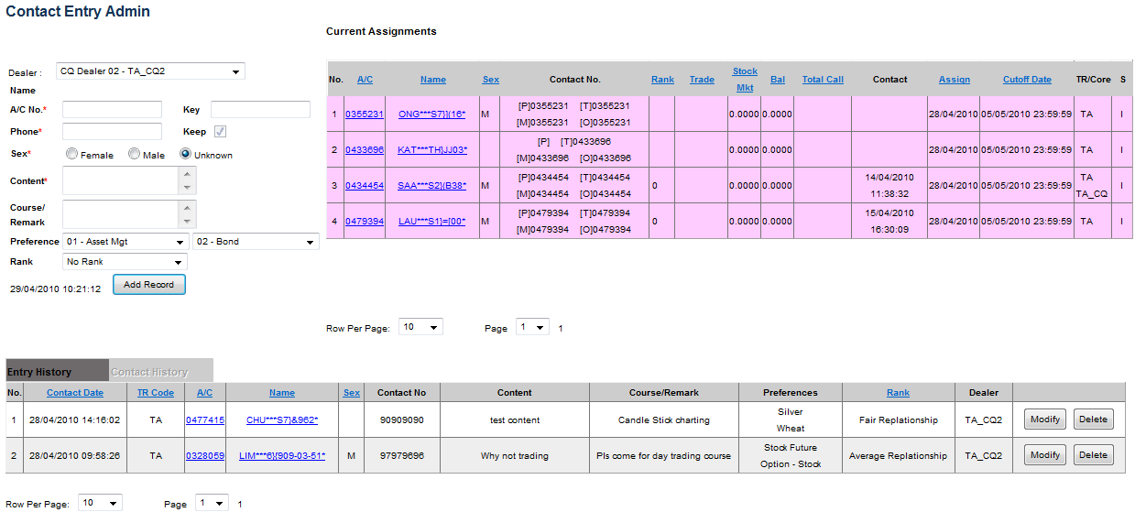
Figure 14 – Contact Entry Screen 1

The rest of the steps are the same as that of Contact Entry function. Refer to “Contact Entry” section for details.

Contact History
This function allows you to retrieve and view contact history records.

Click “Contact History” option on the SPM main menu, system will display Contact History screen.
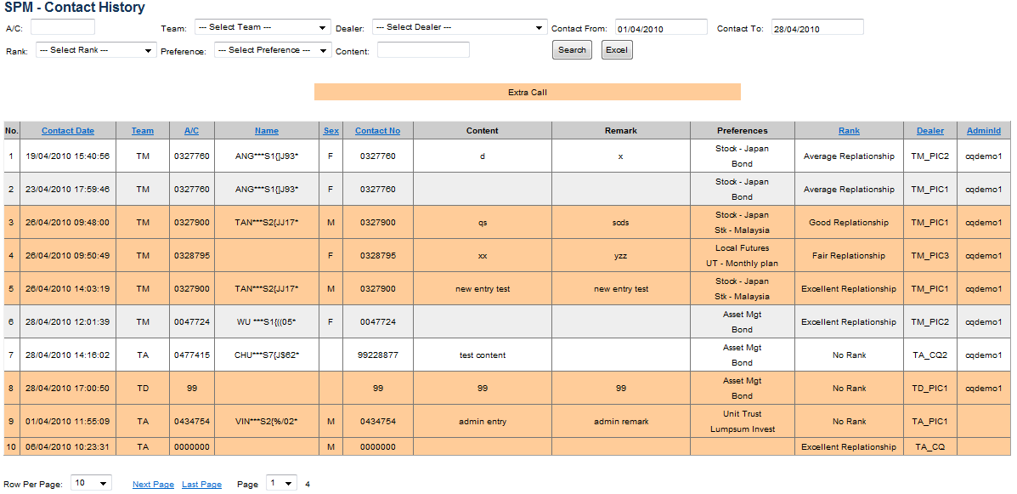
Figure 15 – Contact History Screen

Enter the following search criteria:
- Client A/C number (if you want to search by client A/C number or leave it blank)
- Team (select from team dropdown list if you want to search by team or leave it blank)
- Dealer (select from dealer dropdown list if you want to search by dealer or leave it blank)
- Contact Date Range
- Rank (select from rank dropdown list if you want to search by rank or leave it blank)
- Preference (select from preference dropdown list if you want to search by preference or leave it blank)
- Content (if you want to search by content or leave it blank)

Click “Search” button to search the contact history record that match the search criteria. If no record found, change the search criteria and search again.

Note: the AdminId Column shows the id of the user who entered the contact record on behalf of the dealer assigned.

Refer to “Common Features” section on pagination, export to excel and calendar features.

Call Report
This function allows you to generate dealer’s call report based on assignment date.

Click the “Call Report” option in SPM Main Menu. System will display the Call Report page.

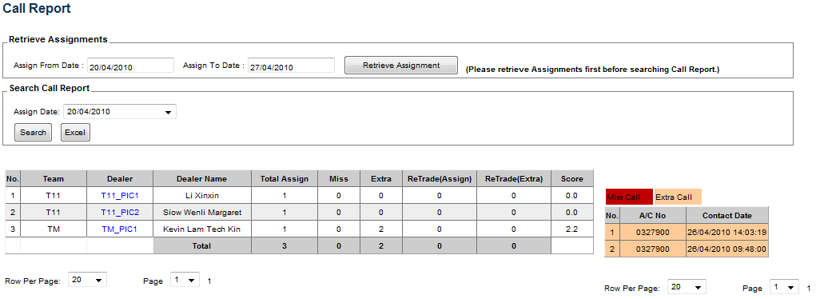
Figure 16 – Call Report Screen

First enter the assignment date range to retrieve a list of assignment dates. You can select date from calendar or enter the date directly. Then click “Retrieve Assignment” button to retrieve a list of assignment date. Select an assignment from the assignment date dropdown list

Click “Search” button to retrieve call report. If no record matching the specified criteria, change the search criteria to search again.

Click the dealer to view the dealer’s Miss Call and Extra Call records.

Refer to “Common Features” section on pagination, export to excel and calendar features.

Contact Analysis
This function allows you to generate contact analysis which will show re-traded clients after contact has been made.

Click the “Contact Analysis” option in SPM Main Menu. System will display the Contact Analysis page.

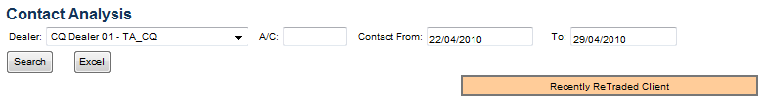
Figure 17 – Contact Analysis Screen

To generate the contact analysis report, enter the following search criteria:
- Dealer (select a dealer from the dealer dropdown list or leave it blank to generate the report for all dealers)
- Client Account No (or leave it blank to generate the report for all clients)
- Contact Date Range

Click “Search” button. System will generate the contact analysis matching the search criteria.

Client Analysis
This function allows you to generate Client Analysis Report.

Click the “Client Analysis” option in SPM Main Menu. System will display the Client Analysis page.

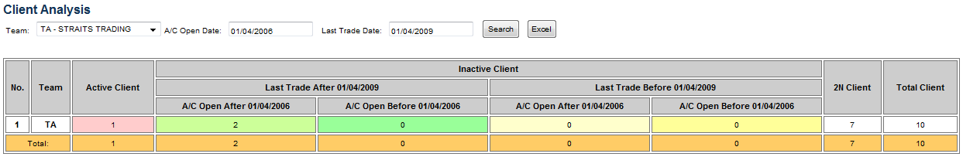
Figure 18 – Client Analysis Screen

Enter the following search criteria:
- Team (select a team from the team dropdown list or leave it blank to generate the report for all teams)
- Client A/C Opening Date
- Client Last Trade Date

Click “Search” button to generate the report that matches the search criteria.

Setup

Core Client Setup
This function allows you to mark clients as core clients for dealers. Only clients belonging to the same team of the dealer can be marked as core clients for the dealer. You can also search and delete the existing core clients. After deleting the core client record, the client will no longer be the core client of the dealer.

Click the “Core Client Setup” option in SPM Main Menu. System will display the Core Client Setup page.

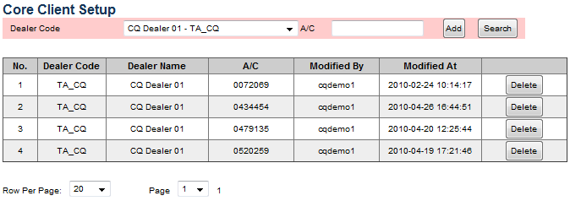
Figure 19 – Core Client Setup Screen

Add Core Client
To add a client as core client for a dealer, select a dealer from the dealer dropdown list and enter the client account number. Click “Add” button to save the core client.

Search Core Client
To search core client, enter the following search criteria:
- Dealer Code (Select from dealer dropdown list or leave it blank)
- Client Account Number or leave it blank

System will display all the core clients matching the search criteria. If no record found, you can change the search criteria and search again.

Delete Core Client
To delete a core client from a dealer, first to search the core client record; then click “Delete” button to delete.

Client Short Key Setup
This function allows you to assign short key to each client. You can search and delete the existing short keys.

Click the “Client Short Key Setup” option in SPM Main Menu. System will display the Client Short Key Setup page.

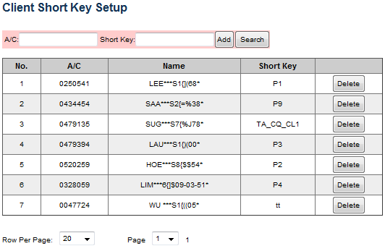

Figure 20 – Client Short Key Setup Screen

Add Short Key
To add a short key for client, enter the client account number and the key. Click “Add” button to save the short key.

Search Short Key
To search a short key, enter the following search criteria:
- Client Account Number or leave it blank
- Short Key or leave it blank

System will display all the short keys matching the criteria. If no record found, you can change the search criteria and search again.

Delete Short Key
To delete a short key, first to search the short key to be deleted; then click “Delete” button to delete.

Dealer Management
This function allows the administrator to manage dealers in SPM system. You will be able to add, search, modify and delete the existing dealers in the SPM system.

Click the “Dealer Management” option in SPM Main Menu. System will display the Dealer Management page.

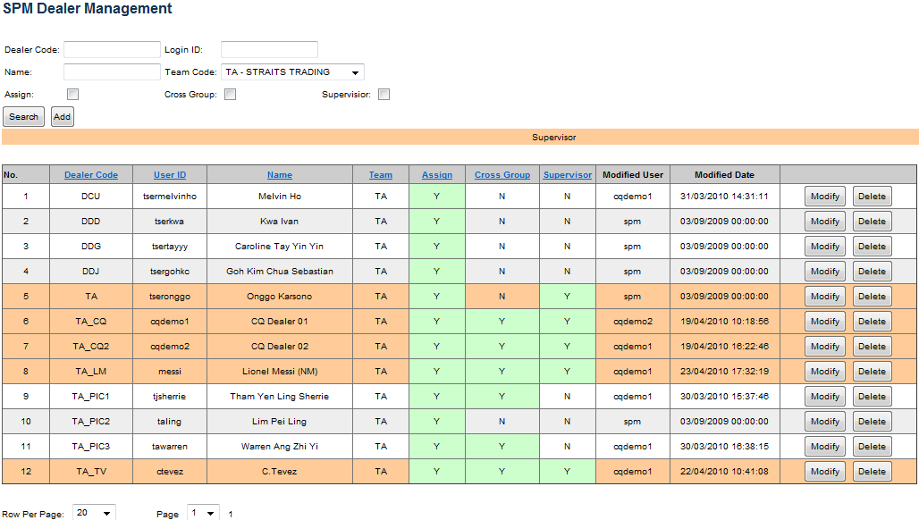
Figure 21 – Dealer Management Screen 1

Create New Dealer
To create a new dealer, enter the following inputs on the top of the screen:
- Dealer Code
- Login ID (POEMS Admin Login ID)
- Dealer Name
- Team Code (select dealer’s team in the team dropdown list)
- Assignment Indicator (tick to allow dealer to be assigned for assignment, un-tick to exclude the dealer for assignment)
- Cross Group Indicator (tick to allow dealer for cross team assignment, un-tick to disallow dealer from cross team assignment)
- Supervisor indicator (tick if the dealer is a supervisor)

Click “Add” button to save the dealer.

Search Dealer
To search dealer, enter the following search criteria on the top of the screen:
- Dealer Code (if you want to search by dealer or leave it blank)
- Login ID (if you want to search by login ID or leave it blank)
- Dealer Name (if you want to search by dealer name or leave it blank)
- Team Code (if you want to search by team; select dealer’s team in the team dropdown list or leave it blank)
- Assignment Indicator (tick if you want to search dealers that can be assigned only; or untick to search regardless of whether dealer is allowed for assignment or not)
- Cross Group Indicator (tick if you want to search dealers who is allowed for cross team assignment only; or untick to search regardless whether dealer is allowed for cross team assignment)
- Supervisor indicator (tick if you want to search only supervisors; or untick to search regardless of whether the dealer is supervisor)

Click “Search” button to search dealers matching the search criteria. If no record found, you can change the search criteria and search again.

Modify Dealer
To modify a dealer, you need to search the dealer first. Then click the “Modify” Button. System will bring up the dealer information on the top of the screen.

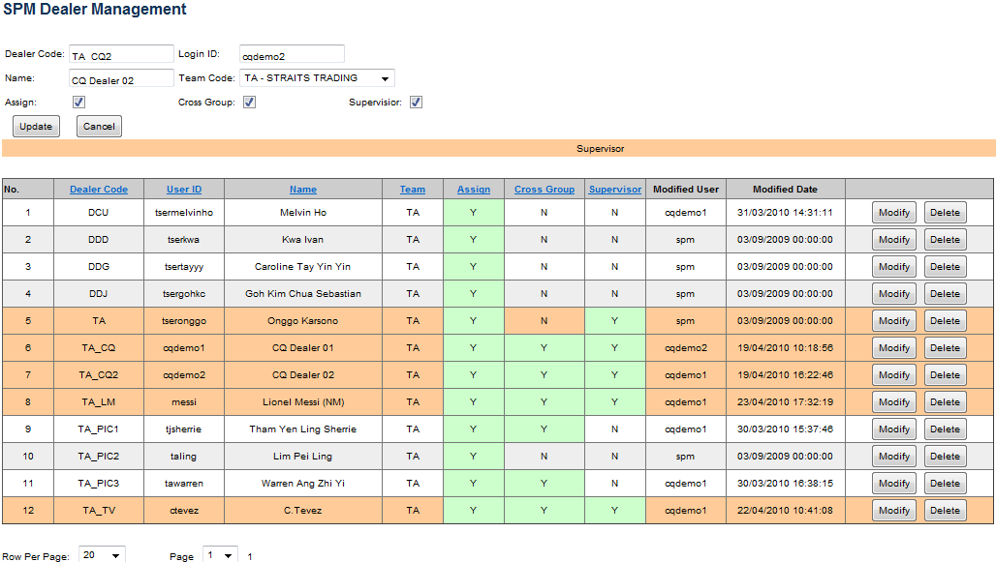
Figure 22 – Dealer Management Screen 2

Change the following information accordingly:
- Dealer Code
- Login ID (POEMS Admin Login ID)
- Dealer Name
- Team Code (select dealer’s team in the team dropdown list)
- Assignment Indicator (tick to allow dealer to be assigned for assignment, un-tick to exclude the dealer for assignment)
- Cross Group Indicator (tick to allow dealer for cross team assignment, un-tick to disallow dealer from cross team assignment)
- Supervisor indicator (tick if the dealer is a supervisor)

Click “Modify” button to save the changes

Delete Dealer
To delete a dealer, you need to search the dealer first. Then click the “Delete” button on the dealer record to delete the dealer.

Cross Team Setup
This function allows the administrator to match dealers to another team for cross team assignment. Only dealers who are allowed for cross team assignment can be matched to another team. You can also view and change the cross team matching.

Click the “Cross Team Setup” option in SPM Main Menu. System will display the Cross Team Setup page.

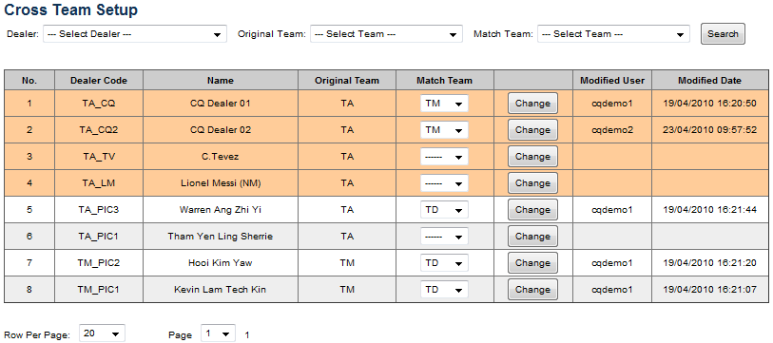
Figure 23 – Cross Team Setup Screen

Search Cross Team Setup
To search cross team setup, enter the following search criteria:
- Dealer (select from dealer dropdown list if you want to search by dealer or leave it blank)
- Original Team (select from team dropdown list if you want to search by original team or leave it blank)
- Match Team (select from team dropdown list if you want to search by matched team or leave it blank)

Click “Search” button to retrieve the dealer matching records that meet the search criteria.

Match Cross Team
To match a dealer to another team, you need to search the dealer first. Then select a matched team from the team dropdown list.

To change a matched team, select another matched team from the team dropdown list.

To remove a dealer from the cross team matching, change to the matched team to empty

Click “Change” button to save the matching.

Preference List Setup
This function allows the administrator to setup client preference list. You can add new preference, search, modify and delete existing preference list.

Click the “Preference List Setup” option in SPM Main Menu. System will display the Preference List Setup page.

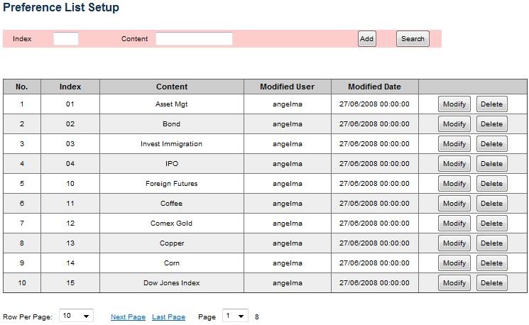

Figure 24 – Preference List Setup Screen

Add Preference
To add a new preference, enter the new index and the name of the new preference in the “Content” field. Click “Add” button to save the new preference.

Search Preference
To search preference, enter the following search criteria:
- Index (if you want to search by index or leave it blank)
- Content (if you want to search by preference name or leave it blank)

Click “Search” Button to retrieve the preferences matching the search criteria. If no record found, change the search criteria and search again.

Modify Preference
To modify preference, first to search the preference record you want to modify. Click the “Modify” button on the preference record. System will fill up the preference index and content at top of the screen.

Change the index or content and click the “Update” button to save the changes.

Delete Preference
To delete preference, first to search the preference record you want to delete. Then click “Delete” button on the preference record to delete the preference.

Access Management
This section is applicable for administrators only.

Before a user can access the SPM system, first the POEMS Admin Administrator should create the user’s login ID in the POEMS Admin system and grant the user access right to “Sales Performance Management” under “Call Center”

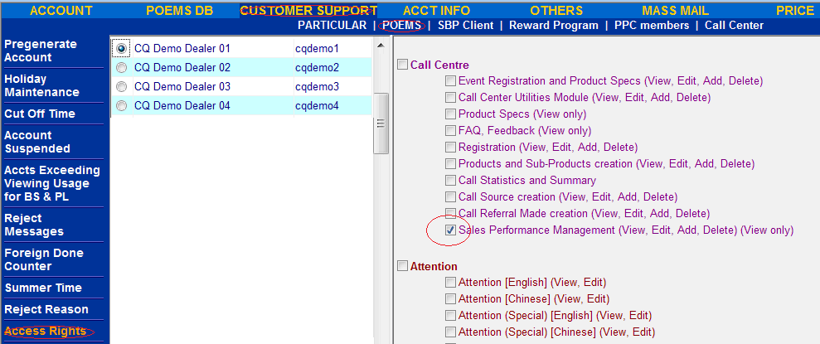

Figure 25 – POEMS Admin Access Rights Management Screen

Then the SPM Administrator needs to create the user information by using “Dealer Management” Function. Refer to “Dealer Management” section for details on how to create a user in SPM.

Then the SPM administrator will go to “Access Management” page to grant user’s access rights to each function. The SPM administrator can also grant additional access rights to user or revoke the existing access rights from user at any time when required.

Click “Access Management” option on the SPM Main Menu, system will display the Access Management page:

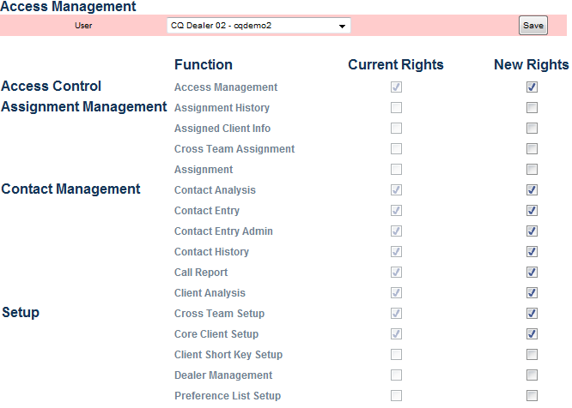

Figure 26 – SPM Access Rights Management Screen

Select a user from user dropdown list, system will display the user’s access rights to each function:
    - Function ticked indicates that the user has the access rights to this function
    - Function un-ticked indicates user has no access rights to this function

To grant the access rights of a function to the user, tick the check box for the function on the “New Access Rights” column.

To revoke the access rights of a function from the user, un-tick the check box for the function on the “New Access Rights” column.

Click “Save” button to save the new access rights.

Glossary

SPM Sales Performance Management system
TR Trading Representative
2N The 2N Rule that define the criteria of a dormant account

